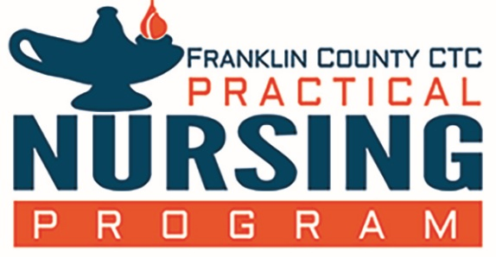
Franklin County Career & Technology Center
Practical Nursing Program
Outcomes and Success Measure

Program Outcome 1: NCLEX-PN performance pass rates will be at least 80% for all first-time candidates during the same 12-month period (Oct 1 – Sept 30). Source: Pennsylvania State Board of Nursing www.dos.pa.gov
Year | National Average | FCCTC-PNP
2023 - 2024 | 89.46% | 100%
2022 - 2023 | 84.49% | 100%
2021 - 2022 | 79.77% | 83.33%
2020 – 2021 | 79.60% | 95.35%

Program Outcome 2: Program completion rate will be at or above 70% (% of students completing the program that started in the cohort of the year listed and completed within 1 year).
Year | % of Students
2023 - 2024 | 55%
2022 - 2023 | 76%
2021 - 2022 | 69%

Program Outcome 3: 90% of graduates seeking employment will obtain employment within one year of graduation.
Year | % Employed in 1 year
2023 - 2024 | 100%
2022 -2023 | 100%
2021 - 2022 | 100%

Jan 2025

